|  |  |
| --- | --- |
| **Ex.No:6.B** | **Insertion Sort** |
|  |

***Aim:***

To develop a python program to perform sorting in a list using insertion sort algorithm.

***Algorithm:***

|  |  |
| --- | --- |
| **Step 1:** | Start Process |
| **Step 2:** | Get a list of numbers from user and store id alist. |
| **Step 3:** | Print “Unsorted list” as alist |
| **Step 4:** | Assign i as zero |
| **Step 5:** | Assign pivot with i |
| **Step 6:** | If pivot greater than zero and alist[pivot] is less than alist[pivot - 1] then goto step 7 |
| **Step 7:** | swap alist[pivot] and alist[pivot-1] and goto step 9 |
| **Step 8:** | Else goto step 9 |
| **Step 9:** | Assign pivot as pivot – 1 and goto Step 6 |
| **Step 10:** | Increment i and compare i with length of alist |
| **Step 11:** | If i is less than length of alist then goto Step Step 5 |
| **Step 12:** | Else print “Sorted list” as alist |
| **Step 13:** | Stop Process |

**Flow Chart:**

**Pseudo Code:**

START

READ alist

PRINT alist

ASSIGN i as 0

WHILE i < length of alist THEN

ASSIGN pivot = i

WHILE pivot > 0 and alist[pivot] < alist[pivot -1] THEN

temp = alist[pivot]

alist[pivot] = alist[pivot-1]

alist[pivot-1] = temp

pivot = pivot - 1

END WHILE

INCREMENT i

END WHILE

**Program:**

print("Insertion Sort")

print("--------------")

alist = []

print ("enter any 5 numbers")

for i in range(5):

data = int(input())

alist.append(data)

print("Unsorted List",alist)

for i in range(len(alist)):

pivot = i

while pivot > 0 and alist[pivot]<alist[pivot-1]:

(alist[pivot],alist[pivot-1]) = (alist[pivot-1],alist[pivot])

pivot = pivot - 1

print("Sorted List",alist)

**Output:**

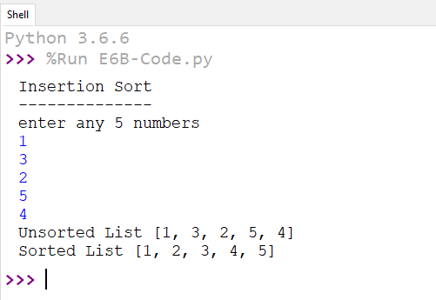

***Result:***

Thus the program to perform sorting in a list using insertion sort algorithm was developed and tested successfully.